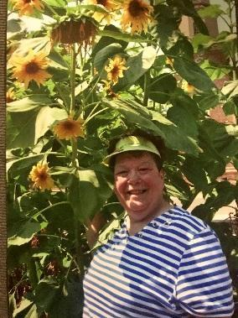 

**THE SUNFLOWER PROJECT: KLEIN FAMILY MEMORIAL SCHOLARSHIP FUND.**

**BACKGROUND:** JANE KLEIN WAS A 46 YEAR RESIDENT OF REYNOLDSBURG WHO HAD A PASSION FOR EDUCATION, LITERACY AND SERVICE TO COMMUNITY. JANE DROVE A SCHOOL BUS FOR REYNOLDSBURG IN THE 1970’S, SERVED ON THE DISTRICT’S BOARD OF EDUCATION FROM 1981-85 AND PARTICIPATED IN COUNTLESS COMMUNITY AND DISTRICT EVENTS THROUGH THE YEARS. HER 2 SONS GRADUATED FROM REYNOLDSBURG HIGH SCHOOL (MICHAEL-1987 & KRIS-1994) AND IT WAS HER WISH TO HELP FUTURE GRADUATES IN ANY SMALL WAY SHE COULD AFTER HER PASSING. JANE PASSED AWAY IN SEPTEMBER 2019 AFTER A SHORT ILLNESS BUT LEAVES A LEGACY OF SERVICE, KINDNESS AND PASSION FOR EDUCATION.

**WHAT:** 2 $500 SCHOLARSHIPS TO REYNOLDSBURG GRADUATING SENIORS WHO HAVE BEEN ACCEPTED TO A 2 OR 4 YEAR ACCREDITED COLLEGE OR UNIVERSITY OR TECHNICAL SCHOOL AND HAS INTEREST IN LITERACY AND SERVING THEIR COMMUNITIES.

**REQUIREMENTS:** MUST BE A STUDENT IN GOOD STANDING WITH A PASSION FOR LITERACY, SERVICE, AND HELP FOR OTHERS.

MUST HAVE MAINTAINED AT LEAST A 2.5 GPA THROUGHOUT HIGH SCHOOL

PLEASE SUBMIT ALL WRITTEN MATERIALS BY **2:00 P.M. ON THURSDAY, APRIL 3, 2025** TO YOUR COUNSELOR:

*A CURRENT RESUME AND SCHOOL TRANSCRIPT.

*A LETTER OF RECOMMENDATION FROM A TEACHER OR COACH.

*A SHORT ESSAY ANSWERING THE QUESTION: **'DESCRIBE A BOOK YOU HAVE READ WHICH HAS INSPIRED YOU AND HOW YOU HAVE APPLIED THAT INSPIRATION INTO YOUR DAILY LIFE?’**

ALL APPLICANTS WILL BE JUDGED BY THE KLEIN FAMILY SCHOLARSHIP COMMITTEE. ALL ESSAYS SHOULD BE SUBMITTED TO YOUR COUNSELOR BY **2:00 P.M. ON THURSDAY, APRIL 3, 2025**. THE WINNERS WILL BE ANNOUNCED AT THE SENIOR AWARDS CEREMONY. ALL SCHOLARSHIP MONIES WILL BE AWARDED TO THE WINNERS INDIVIDUALLY BY CHECK.